Hello everyone how is it going? I am going to give a rating of how hard something maybe when we are making pages. The scale will be from 1 to 5.

**1 - easy, maybe 30 minutes to 1h**

**5 - hard, will take time and research maybe 5h or more depending on how polished you want it**

The main focus will still be the same as followed: The calender portion, then the budgeting, and everything else.

Pages we have to make:

**Login - 1**

**Register - 1**

**Calendar - Month - 5**

[**Android | Creating a Calendar View app - GeeksforGeeks**](https://www.geeksforgeeks.org/android-creating-a-calendar-view-app/)

[**Calendar App Example Android Studio Tutorial - YouTube**](https://www.youtube.com/watch?v=Ba0Q-cK1fJo&ab_channel=CodeWithCal)

<https://stackoverflow.com/questions/4823851/multi-state-toggle-button>

**Calendar - Week - 4**

[Weekly Calendar Android Studio Tutorial | Daily Events List - YouTube](https://www.youtube.com/watch?v=knpSbtbPz3o)

**Calendar - Day - 3**

[Daily Calendar View Android Studio Tutorial - YouTube](https://www.youtube.com/watch?v=Aig99t-gNqM)

**Add event [a floating page] - 2**

**Profile - 3**

**Notes - 3**

**Create Note - 3**

**Budget - Pie Chart - 3**

**Budget - List - 2**

OTHER LINKS

Create multi-switch toggle [for M/W/D]: <https://stackoverflow.com/questions/4823851/multi-state-toggle-button>

Alright, about 11 pages.

How I see the breakdown is based on SIMILAR work, not about balancing work here

1 - login + register = 2

2 - Notes + Users = 6

3 - Calendar - M = 5

4 - Calender - W + D = 7 (they are similar to what we have done if you want to make them separate that's an option too)

5 - create event + create note = 4

6 - Budget - Pie + List = 5

| Work | Assigned to |
| --- | --- |
| 1 and 5   * Login * Register * Create event * Create note |  |
| 2   * Notes * user |  |
| 3   * Calender Month |  |
| 4   * Calender Week * Calender Day |  |
| 6   * Budget * Pie |  |

Login - 1 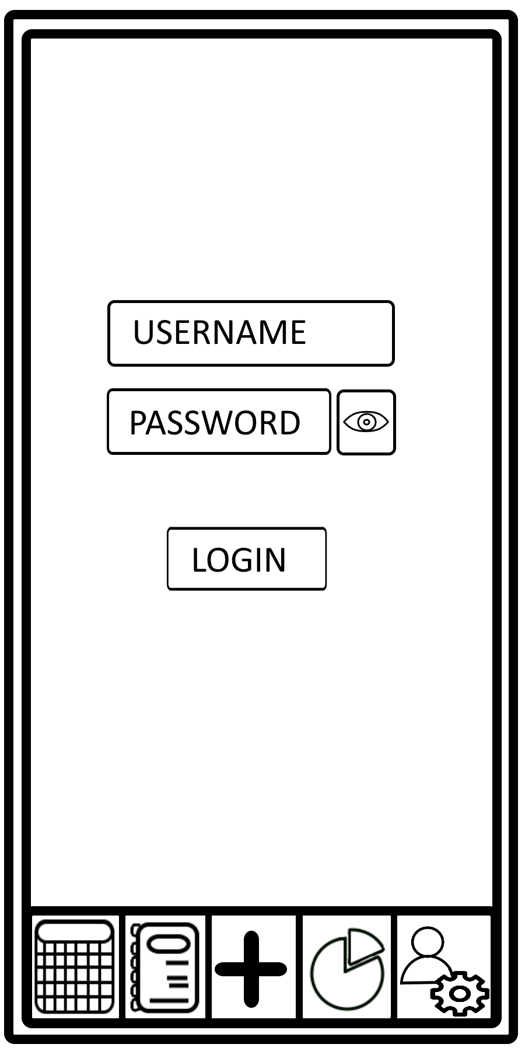

Edit text - Username

Edit text secure - password

Button - view password

Button - login

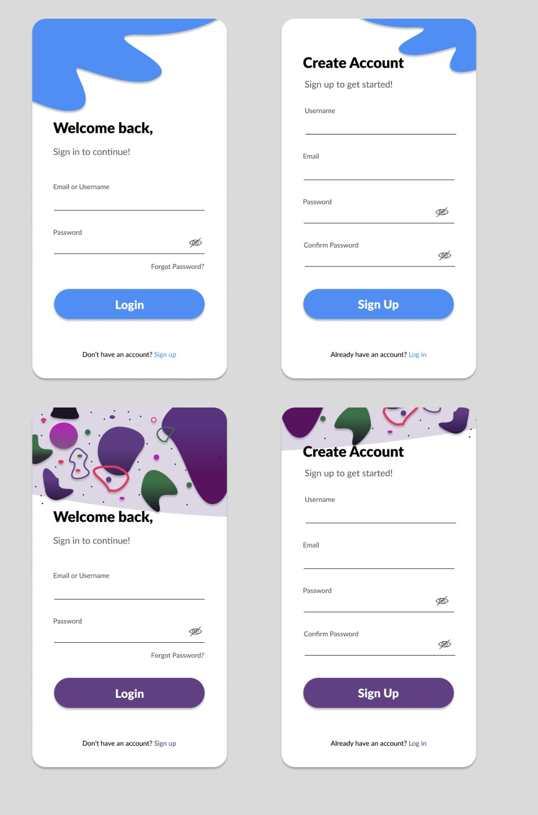

Register - 1

Edit text with hints:

* Username
* Email
* Password - secure
* Confirm password - secure
* Button to check password typing
* Button to check password typing
* Sign up button
* Sign in text button

Calendar - Month - 5 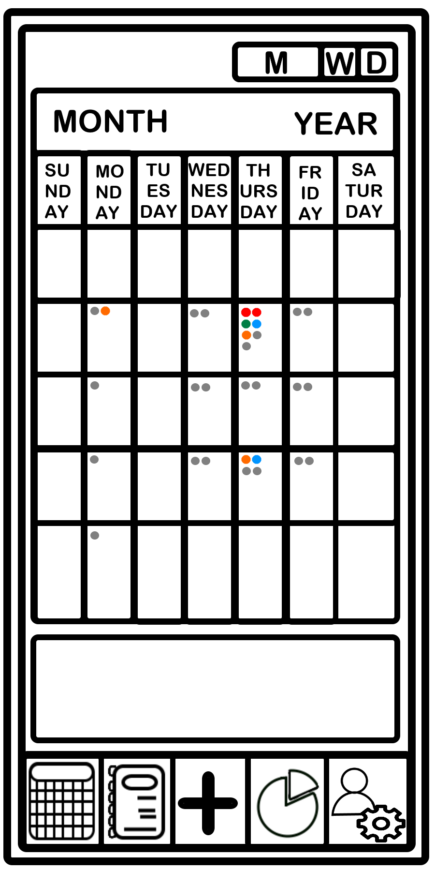

Just check a youtube video

Calendar - Week - 4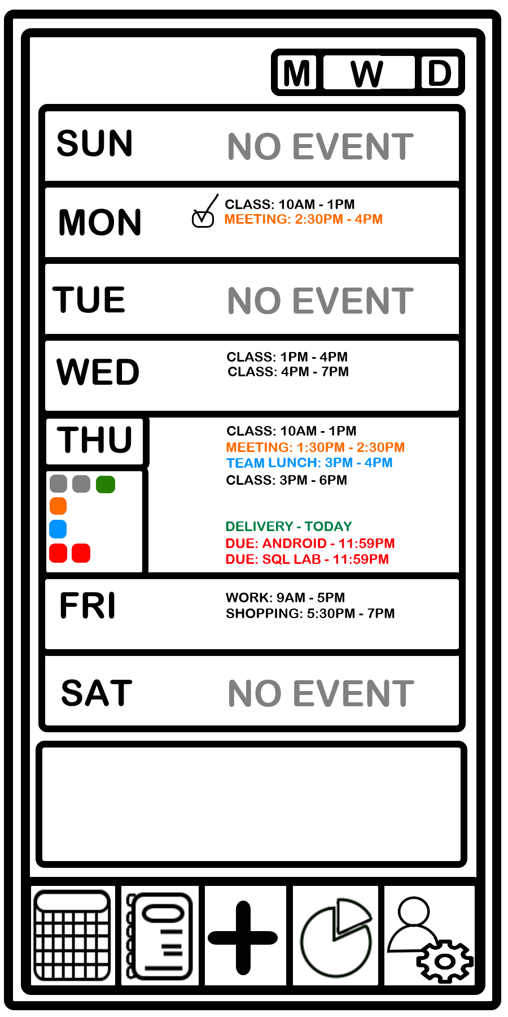

[Weekly Calendar Android Studio Tutorial | Daily Events List - YouTube](https://www.youtube.com/watch?v=knpSbtbPz3o)

* Manually if you want:  
  Make a constraint for each day
* Each day has a collapsable constraint -shrink vs expand
* Those boxes are a visual representation of types of events: important, urgent, etc
* At collapse - make a line of boxes under the day, and prioritize anything important
* At expand, split day with list of whats happening that day with a bulletin in different colors

Calendar - Day - 4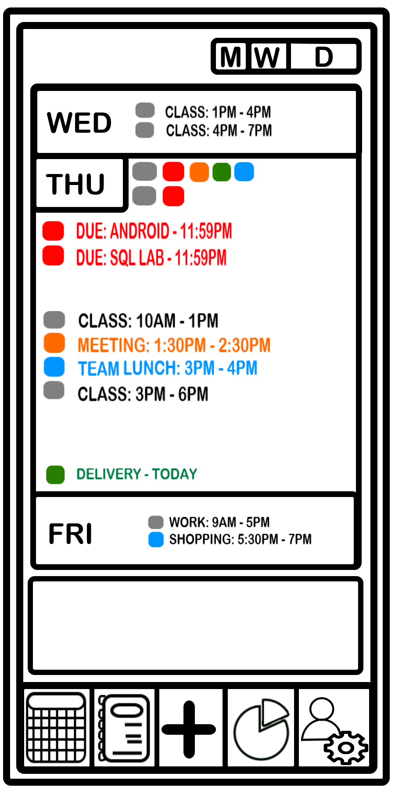

[Daily Calendar View Android Studio Tutorial - YouTube](https://www.youtube.com/watch?v=Aig99t-gNqM)

Very similar to weekly work, just broken down into: current day, past day, next day

Add event [a floating page] - 2

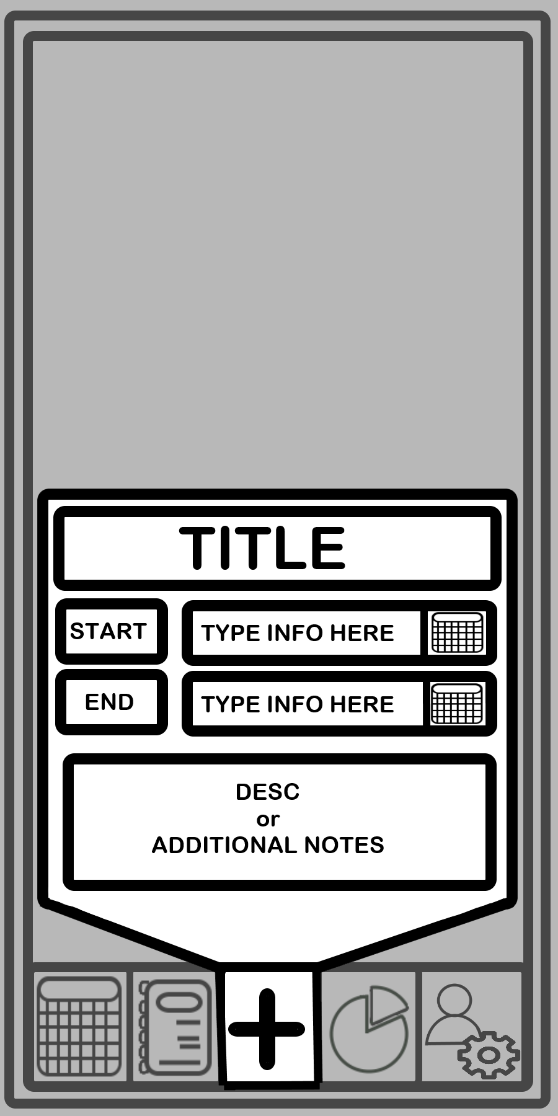

Minor change: push the box to the top. Forgot to consider the keyboard popup, so use the top half of the screen for the page

Constraint

Edittext - title

Textbox - start

Textbox - end

Edittext with ‘calendar search’

Scroll view with edit text inside

Profile - 3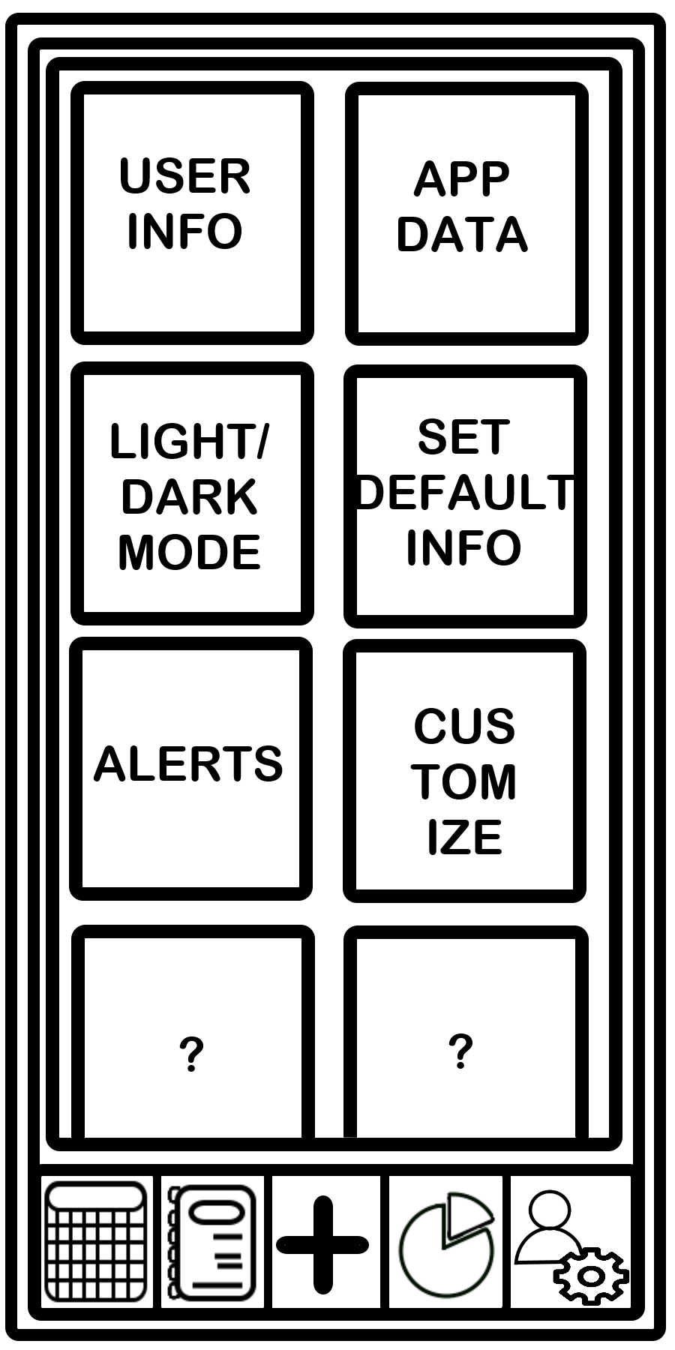

CHANGE IN DESIGN

Tile system like this, but keep them horizontally complete to hold user information, so no small pages

Some items can expand to take up more space

Switch toggles maybe

All in a scroll view just incase - if all information is expanded

Notes - 3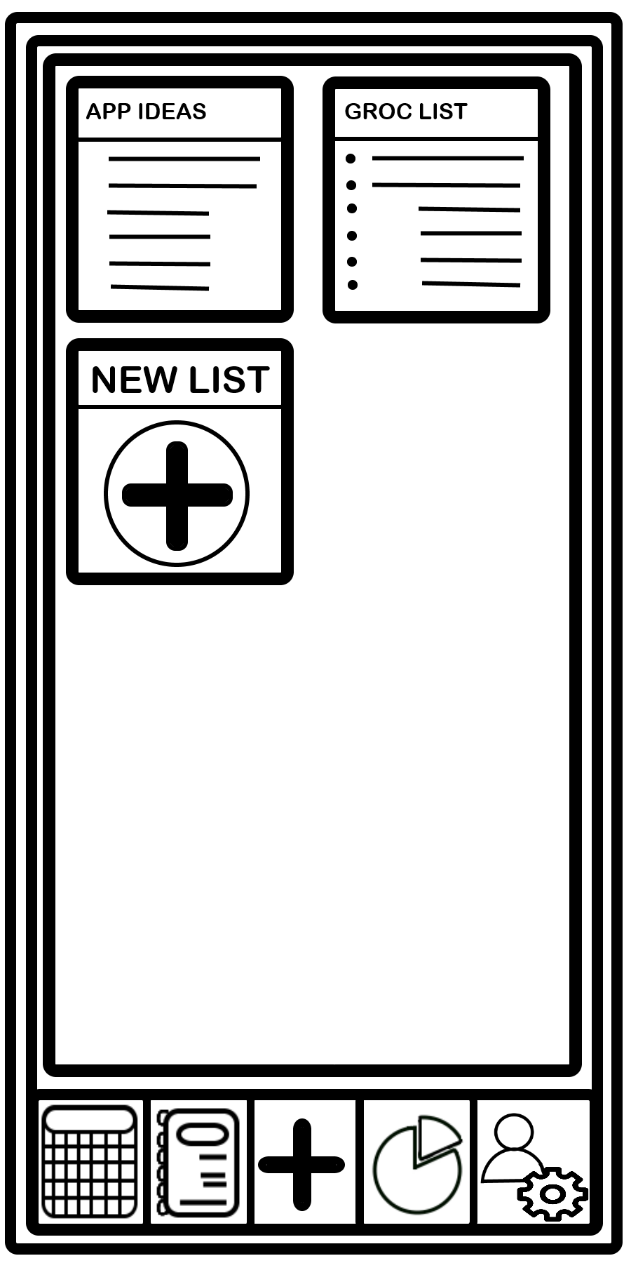

Should hold a list of lists created

That list should be shown visually something like this or horizontal tiles like user profile

Create Note - 3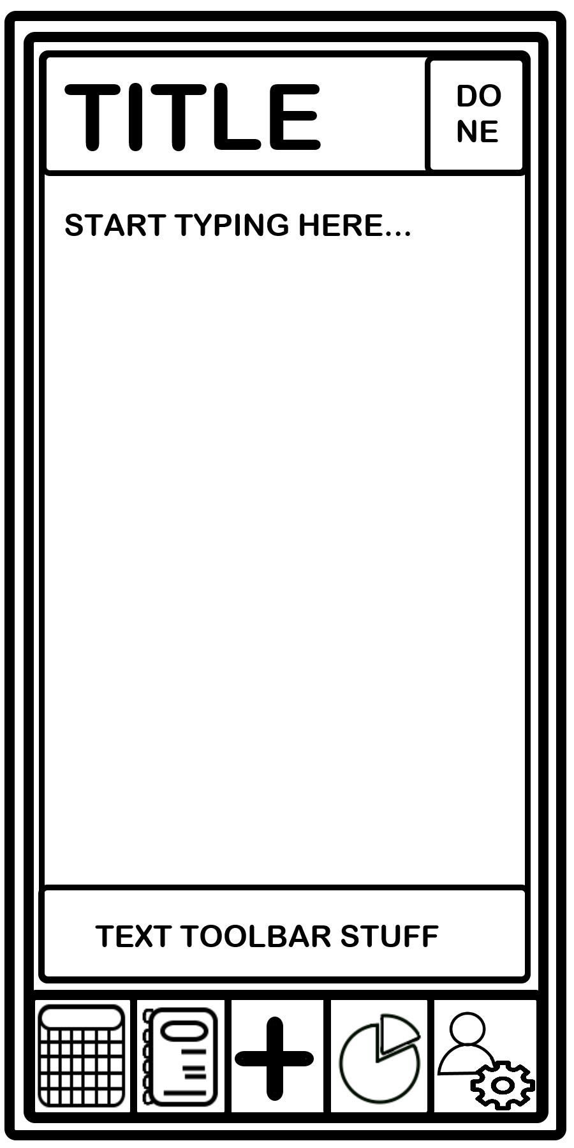

Title block,

button ‘done’

Edit text inside a scroll view

Bottom section constraint

Budget - Pie Chart - 3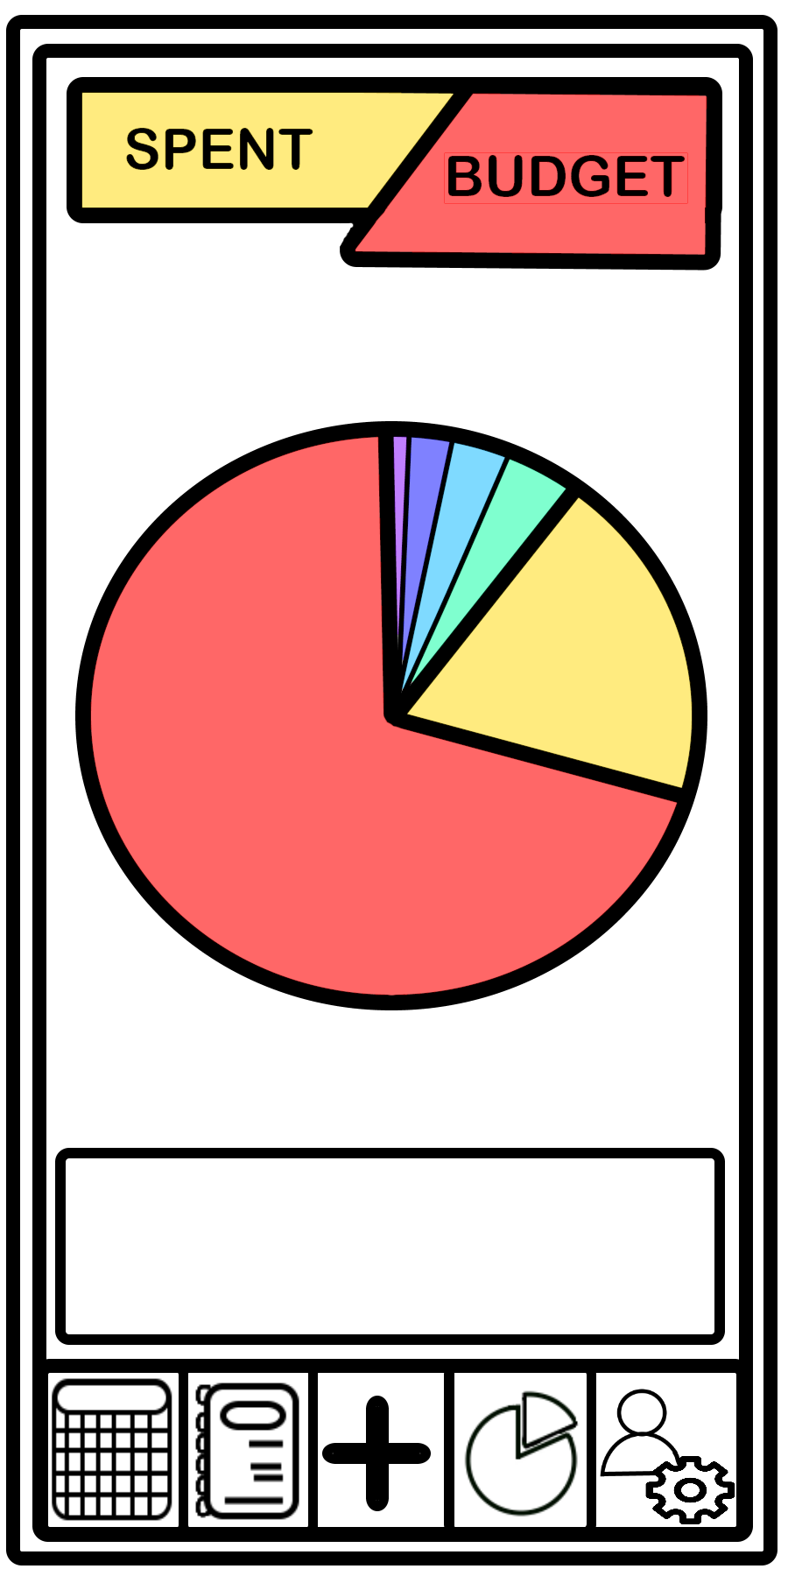

Textview - update based on current cash

Textview - your budget limit

Piechart - based on data provided

Throw in a picture for now maybe/ but keep a link toward something to show a chart

Budget - List - 2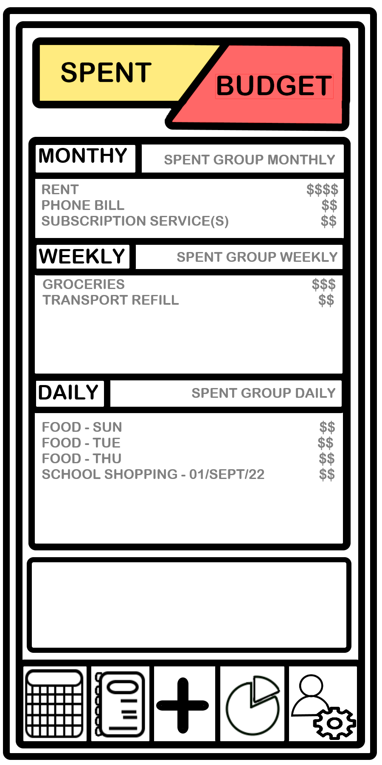

* Textview - changing/updating
* Textview - budget - static
* Constraint
  + 3 sections:
  + Month, week, day - collapsable maybe
  + All wrapped in a scroll view?
  + Shows you information
    - Textview
    - Button/interaction to compress